C H R I S T O J O N E S

"There's a beautiful danger to the way Christo Jones layers his music. The result is textured and sonically impressive soundscapes. I suspect many artists will be looking at this project thinking, 'I wish I could do that'."
- Lars Brandle, Australian Billboard Correspondent

Christo Jones is a solo artist from Sydney who uses a self-built rig overflowing with guitars, keyboards, samplers and pedals to write, record, loop and perform epic, melodic, beautifully twisted tunes.

Not only is the method Christo uses to build the songs (before your very eyes) original, inspiring and a sight to behold, the songs that result are equally so. Folk, soundscape and pop vie for attention as his arrangements build to ecstatic crescendos under Christo’s commanding voice.

After wowing 2,000 delegates and thousands of live YouTube viewers at Sydney's TED Talks, Christo Jones took Sydney’s live venues while recording his debut EP with Dan Johnston (producer of award winning indie-pop act kyü).

Christo Jones' debut single 'Anyway' has received glowing reviews, was selected for regular playlist rotation on Sydney's premier indie station FBi Radio and triple j unearthed digital radio, and is getting airplay on community radio Australia-wide including Melbourne's Triple R and Brisbane's 4ZZZ.

Christo’s music has drawn comparisons to Jonathan Boulet and Dirty Projectors and to some, a little taste of The Flaming Lips and The Polyphonic Spree, while his vocals often remind people of Ian Curtis.

Sound like a mishmash of colourful, unique and delightful sounds? It is. And that is without a doubt part of it's charm.

"Though one would assume Christo’s "one man multi-instrumentalist" sound to be a familiar one, the intricacies of his music and performance are nothing short of spellbinding and - dare I say – unique. With a huge sound that makes you think of bands like The Polyphonic Spree rather than a Xavier Rudd, with Christo Jones you can certainly expect the unexpected." – Larry Heath, The [AU] Review

“'Anyway' is a monumental layering of sounds and lyrical charm that make for an aural feast, something new can be heard each listen." - Undercover.fm

"Christo Jones makes a big impression with his debut single 'Anyway'. This is such a rich, lush song. It’s so exciting to uncover an artist who’s truly shaking things up. Expect to hear big things from Christo Jones.” - Sounds of Oz

Download Music & See Live Videos At: www.christojones.com
Press Contact: Jess Beston, Tiny Monster / jess.beston@tinymonster.com / 0447 774 808
Bookings: Chris Johnson / music@christojones.com / 0428 230 017
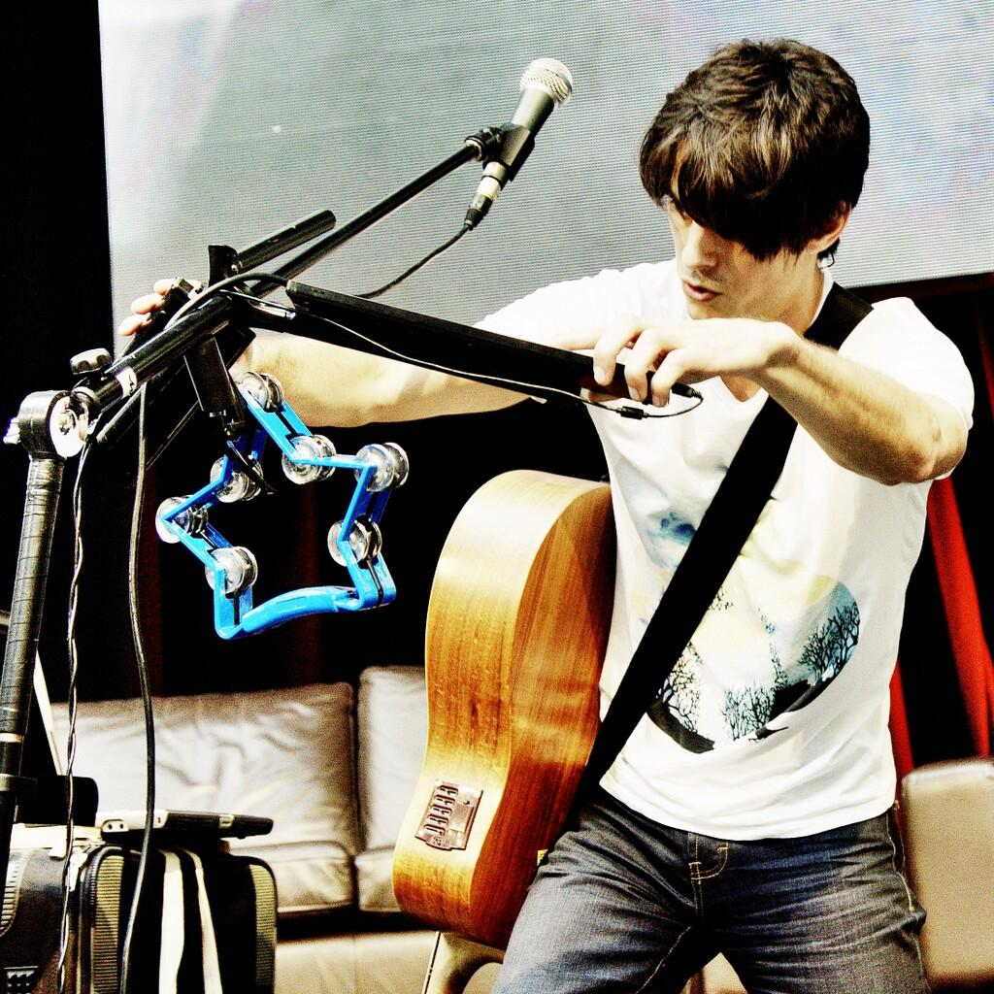 | 